**Speech Recognition using Elechouse’s VR3 and Arduino-**

**STEP 1: Training the module**

The module was trained using VoiceRecognitionV3 library by Elechouse. The four commands recorded were-

Command VR index

ONE 0

TWO 1

THREE 2

FOUR 3

For this purpose, following connections were made-

Arduino pin VR3 module

+5V VCC

GND GND

2 TXD

3 RXD

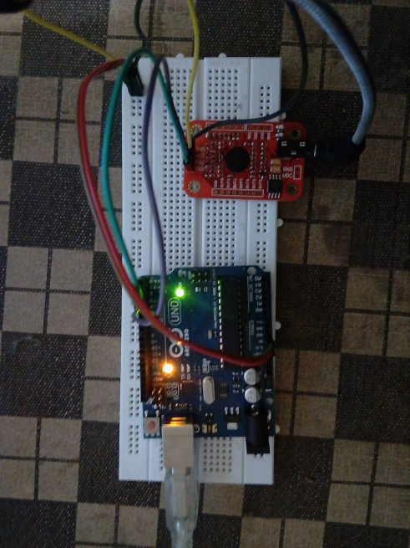

Next, using Arduino, Arduino IDE and vr_sample_train.ino sketch, the module was trained using the serial monitor and microphone.

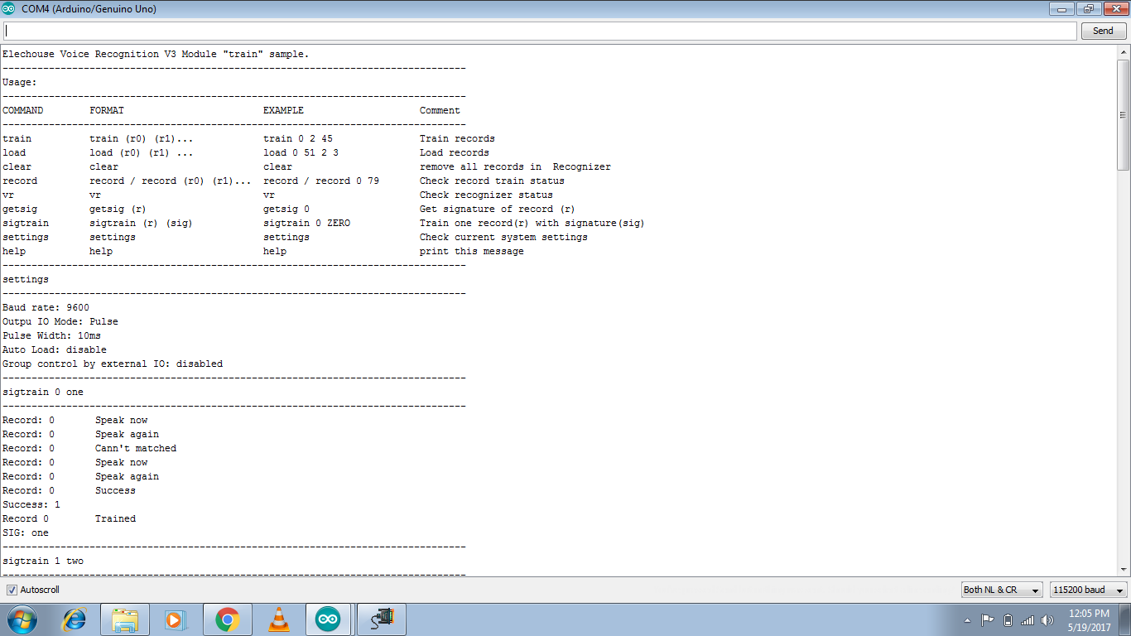

Training the module using vr_sample_train.ino

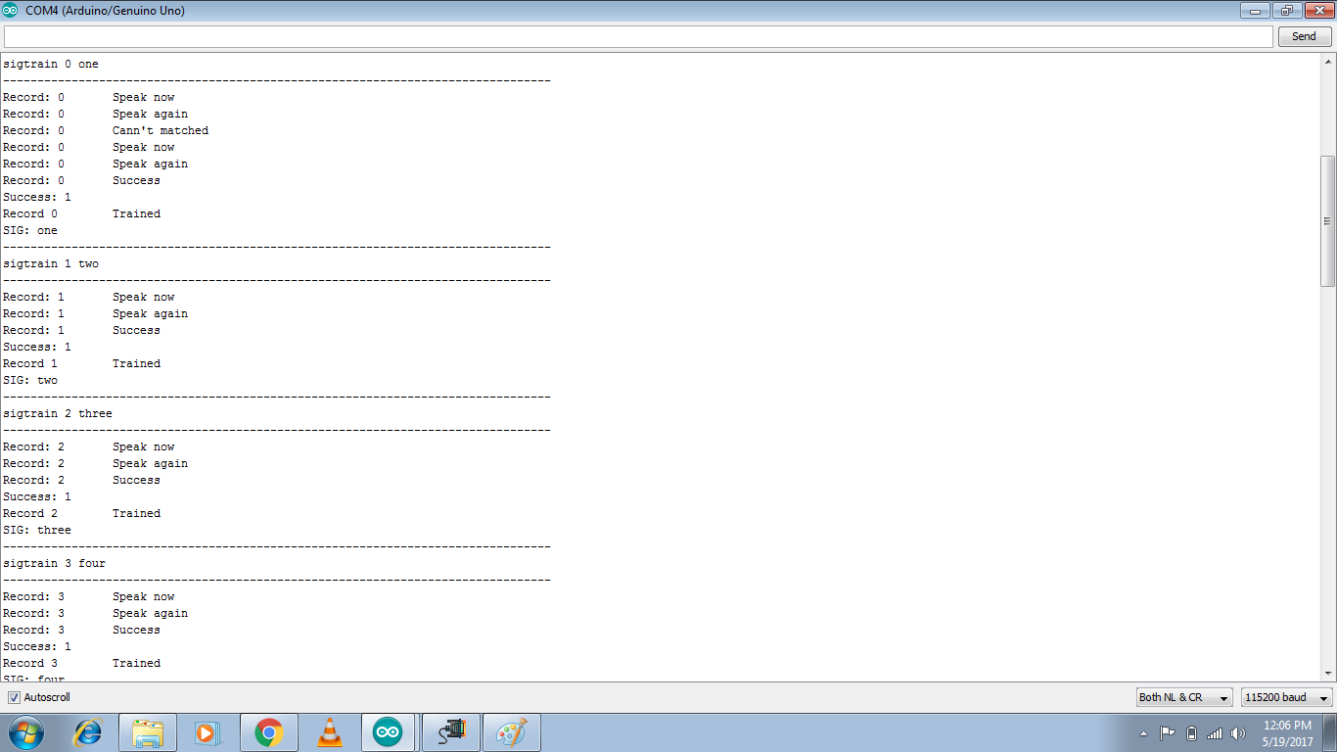

Training the VR3 module

**STEP 2: Arduino IDE sketch**

#include <SoftwareSerial.h>

#include "VoiceRecognitionV3.h"

/**

Arduino

2 -------> VoiceRecognitionModule TX

3 -------> VoiceRecognitionModule RX

8 -------> Red LED

9 -------> Green LED

10 -------> IR sensor Ouput

A0 -------> Temprature sensor Output

*/

VR myVR(2,3);

uint8_t records[7]; // save commands that were previously recorded during VR3 training

uint8_t buf[64];

int led1 = 8;

int led2 = 9;

int temp = A0;

int ir = 10;

int irval=0;

int tempval=0;

#define LED1 (0)

#define IRsense (1)

#define tempsense (2)

#define LED2 (3)

void setup()

{

myVR.begin(9600);

Serial.begin(115200);

Serial.println("Voice recognition using V3 module");

pinMode(led1, OUTPUT);

pinMode(led2, OUTPUT);

pinMode(temp, INPUT);

pinMode(ir, INPUT);

if(myVR.clear() == 0){

Serial.println("Recognizer cleared.");

}

else{

Serial.println("Not find VoiceRecognitionModule.");

Serial.println("Please check connection and restart Arduino.");

while(1);

}

if(myVR.load((uint8_t)LED1) >= 0){

Serial.println("LED1 Record loaded");

}

if(myVR.load((uint8_t)IRsense) >= 0){

Serial.println("IRsense Record loaded");

}

if(myVR.load((uint8_t)tempsense) >= 0){

Serial.println("tempsense Record loaded");

}

if(myVR.load((uint8_t)LED2) >= 0){

Serial.println("LED2 Record loaded");

}

}

void loop()

{

int ret,c=0;

ret = myVR.recognize(buf, 50);

if (buf[1]==LED1)

c=1;

else if (buf[1]==IRsense)

c=2;

else if (buf[1]==tempsense)

c=3;

else if (buf[1]==LED2)

c=4;

switch(c){

case 1:

Serial.println("Command <one>. Blinking RED LED..");

digitalWrite(led1, HIGH);

delay(500);

digitalWrite(led1, LOW);

delay(500);

break;

case 2:

Serial.println("Command <two>. Printing value of IR sensor..");

irval=digitalRead(ir);

Serial.println(irval);

delay(500);

break;

case 3:

Serial.println("Command <three>. Printing value of Temprature sensor..");

tempval=analogRead(temp);

Serial.println(tempval);

delay(500);

break;

case 4:

Serial.println("Command <four>. Blinking GREEN LED..");

digitalWrite(led2, HIGH);

delay(500);

digitalWrite(led2, LOW);

delay(500);

break;

default:

Serial.println("Record function undefined");

break;

}

}

**STEP 3: Running the code**

The audio commands were successfully executed during run-time. The code is carefully written to only detect voice commands and not silence or arbitrary values. In this way, a command will execute continuously until another valid command is recognized.

